Project Development Phase
Date | 13 July 2026
Team ID | SWTID-2026-4732
Project Name | India's Agricultural Crop Production Analysis
Maximum Marks

Dash Board:
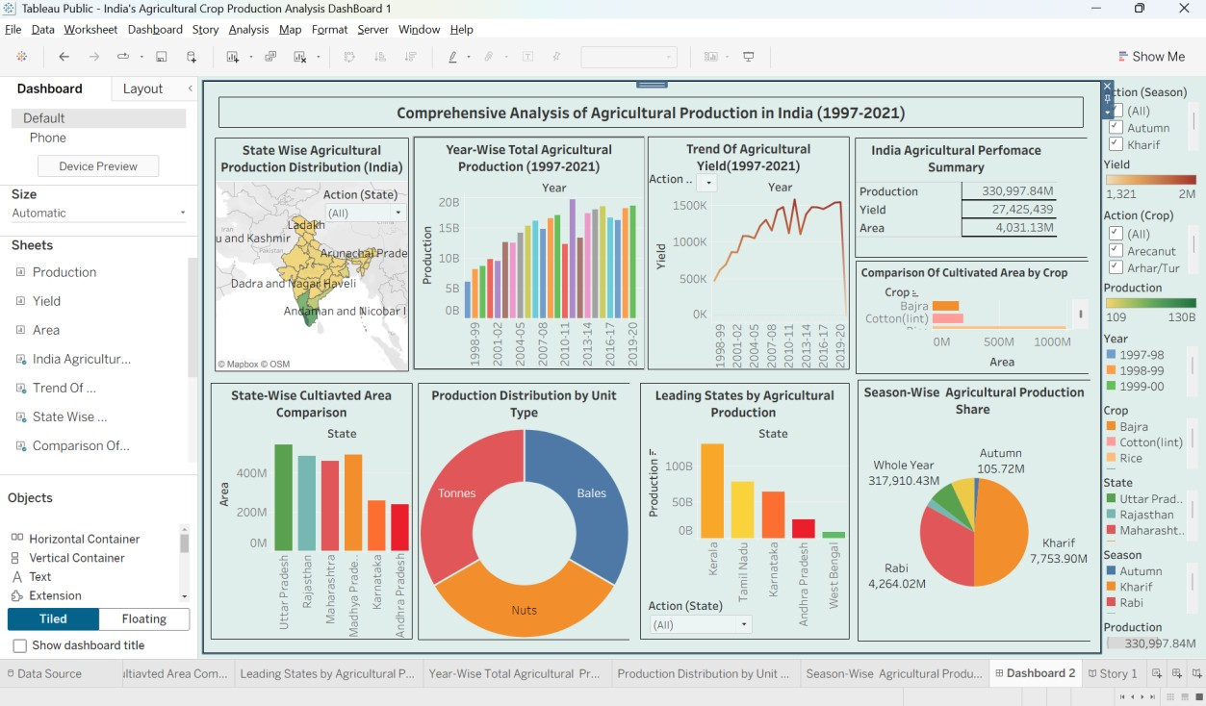
Story:
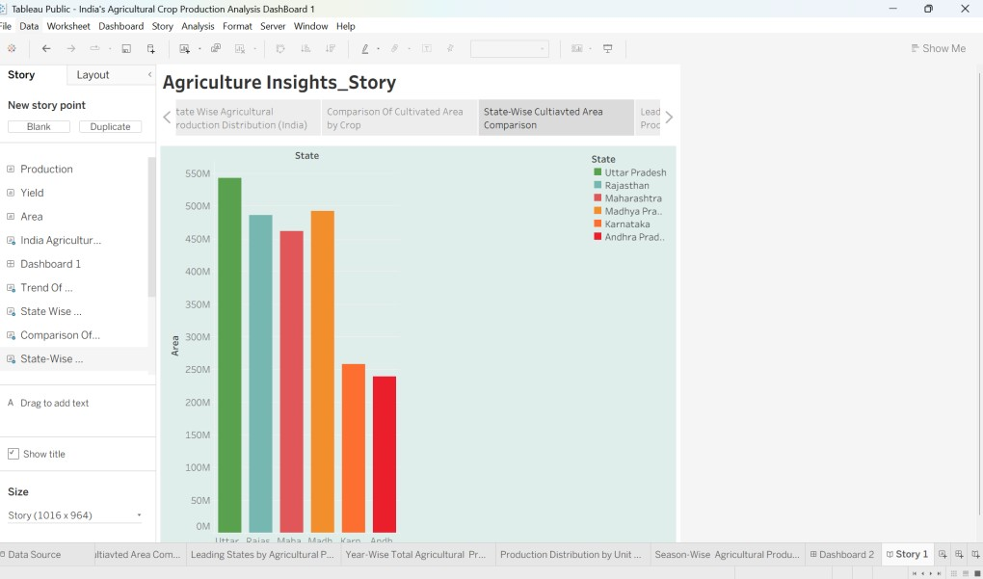
Tableau Public Links:
Dash Board Link:
https://public.tableau.com/views/IndiasAgriculturalCropProductionA nalysisDashBoard1/Dashboard2?:language=en-
US&:sid=&:redirect=auth&:display_count=n&:origin=viz_share_link Story:
https://public.tableau.com/views/IndiasAgriculturalCropProductionA nalysisStory_17827330156970/Story1?:language=en-
US&:sid=&:redirect=auth&:display_count=n&:origin=viz_share_link

